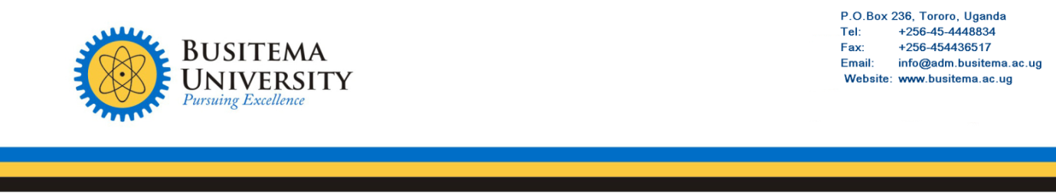

ESTATES UNIT

To: University Secretary

Thru: University Bursar

Thru: Programme Controller
From: Ag. AEO. (Mech.) Simali Habert 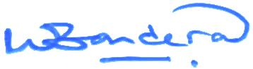

Date: April 8, 2026

SUBJECT: INSPECTION REPORT FOR MOTOR VEHICLE REG: NO. UBA 342B.

S/N | INSPECTION POINT | STATUS | REMARKS
1. | Routine maintenance | Previous service: 393,519Km  Current mileage: 398,124Km  Next service: 398,519 Km | Vehicle routine service mileage will be due in the next 395KM. Motor vehicle need to be forwarded to the service provider for routine maintenance works.
2. | Suspension system | Worn out Tyres.  Tyre Size: 245/70R16  Load/Speed index: 112H | ALL the Five (5) Tyres be replaced with the exact specifications as provided by the manufacturer.
3. | Braking system. | - Poor brake response.  - Irresponsive emergency/parking brake. | Front brake pads and rear brake shoes worn out and need to be replaced.
4. | Body. | - Body paint degradation.  - Abrasion damage on some parts of the body especially the front bumper. | Full body works are recommended for full restoration of body looks.
5. | Lighting system. | Left front fog light casing and reflector damaged. | Fog light be replaced with a new one for improved lighting.
6. | Licenses and insurance. | Expired motor third party insurance.  Issue date:23/01/2025  Expiry date: 22/01.2026 | Insurance be purchased for compliance with the traffic and road safety act 1998.

The purpose of this report is to therefore request you authorize repair and maintenance works on this vehicle.

Thank you.
CC: Senior Estates Officer.

